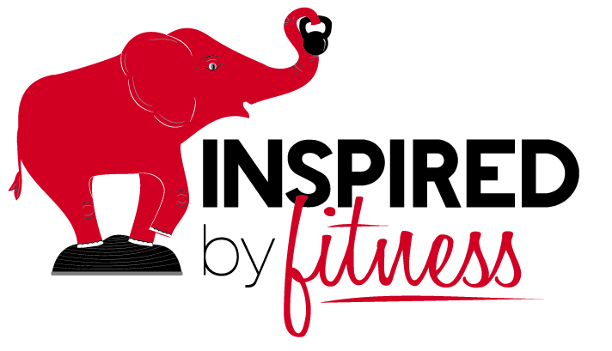
www.inspiredbyfitness.net
"Creating Healthy, Active Lifestyles for a Lifetime.
One Bite At A Time, One Healthy Choice At A Time, One Day At A Time"

RATE ADJUSTMENT EFFECTIVE May 15, 2016

Customized Personal Training & Health Coaching
*Includes session time Plus additional time spent in session prep, follow up, Nutrition Counseling and other Fitness, Health & Wellness Resources.

One-On-One Private Training 6 Sessions Package (5% Discount)
30 Minutes $45 $256
45 Minutes $55 $313
1 Hour $75 $427
One on One Private Training at Your Location* 6 Sessions Package (5% Discount)
45 Minutes $80 $456
1 Hour $100 $570

Semi-Private (Group of 2 People/Couples) 6 Sessions Package (5% Discount)
1 Hour $95 $542
* Your Location $125 $712

Small Group Fitness "Class Style" (3-4) 45 Minutes - $60-75 30 Min. Express - $50
*For Onsite Group Training/Classes, rates dependent on location and group size
Grocery Shopping & Menu Planning Trip $75 (learn how to navigate, read & understand nutrition labels and Menu Plan & Prep). Pantry/Kitchen Clean Out & Prep - $75
For Virtual Training - Health Coaching and/or Personal Training, check out Virtual Training Services (MORE AFFORDABLE OPTIONS)
For Corporate Wellness Program Services, Wellness Lunch & Learn Workshops and On-Site Classes or Healthy Lifestyle and Empowerment Workshops, Contact Susan
*CANCELLATION & NO REFUND POLICY: Cancellations require a Courtesy 48-hour notice. Missed sessions will be invoiced or counted as a paid session. This not only helps enhance your accountability with your fitness training commitment to yourself, but also allows us to schedule another client in your timeslot. No refunds will be given back for prepaid sessions or packages. Thank you in advance.

